Group Proposal Team-Student #5

800 W Campbell Rd

Richardson, TX 75080-3021

December 7, 2014

Mark W. Spong

Dean, Erik Jonsson School of Engineering & Computer Science

University of Texas at Dallas

800 W Campbell Rd

Richardson, TX 75080-3021

Dear Mr. Spong:

We are pleased to submit a new proposal for upgrading the Engineering and Computer Science building restroom facilities from standard (mechanical) faucets to touchless faucets. This new proposal will offer the university an opportunity to create a substantial amount in savings thanks to the reduced use in water, reduced maintenance and operations costs, and the extended lifecycle of the faucets.

Touch free fixtures help reduce the spread of germs and other contagious infections in addition they are convenient and simple for users to activate, while helping facility managers keep the restrooms clean and lessening the maintenance. Their touchless design reduces wear and tear from usage and minimizes the opportunities for vandalism.

All around the world, people use water in their everyday lives. For many, water is limited, and usage is a deliberate action, consuming only what is necessary. For the more fortuitous, water is regarded as a resource that is infinite, an abounding wealth that appears whenever a faucet is turned on. Most of us identify with the latter and when we use water, we don’t consciously think about where it comes from, where it’s going, and most importantly, how much we’re using. Yet, there are as many as two billion people in the world who live at odds, and attaining clean water is a painstakingly real process. The truth is that water is not an unlimited resource, and the uneven distribution of water is in large caused by unsustainable management and waste.

Demonstrating your commitment to water efficiency will make a positive impression on your staff and the students. We can all do our part to use water more effectively, thereby improving water quality and preserving our drinking water resources.

We hope that the budget commission will consider this proposal as something significant that can help the university, the students and faculty. Please do not hesitate to get in touch with us for any further inquiry about the proposal or if additional information is needed.

We look forward to hearing from you.

Yours sincerely,

Group Proposal Team

800 W Campbell Rd

Richardson, TX 75080-3021

Faucet Trouble –Student #1  
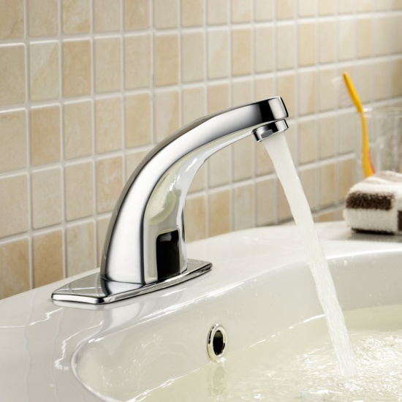The University of Texas at Dallas serves thousands of students every day. Many of them use the bathrooms, and such a large volume of people naturally causes bathrooms to have low hygiene and can cause illnesses to be spread easily throughout the student populace. Bad hygiene is a constant problem at many public places and is one of the most difficult things to reduce, if not eliminate completely. One way bathrooms at UT Dallas can increase their sanitation level is by replacing the manual water faucets with electronic, sensor activated, faucets. This proposal will be regarding the implementation of electronic faucets in place of manual faucets for the Engineering and Computer Science Building (ECS) at the University of Texas at Dallas. Electronic faucets have many advantages over traditional manual faucets such as increasing the hygiene level of the bathrooms, reducing water consumption, and helping to modernize an aging building.

Figure 1 Lykor Automatic Faucet

## **The Texas Drought**

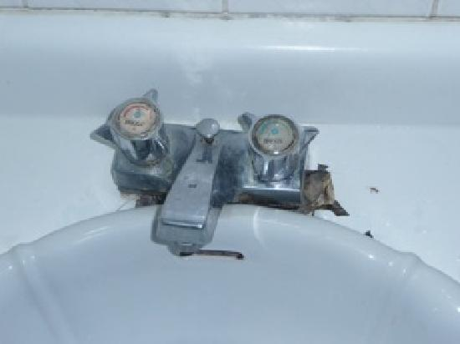Reducing water consumption is a big issue for UT Dallas as the State of Texas has been facing a severe drought for over five years. In 2010 UTD finished construction of its first Platinum certified LEED building, the Student Services Building (SSB). One of the things that is touted on the UT Dallas Sustainability website is the water conservation within the SSB. “The building’s design accommodates water conservation practices for Texas, a region that is notorious for experiencing long periods of drought, incorporating measures such as: Automatic sensors in faucets…” In 2011 UT Dallas took extra precautions to help conserve water. One of these precautions included “A preventive maintenance sweep has been completed throughout campus to identify and eliminate dripping faucets and leaks.” Indeed during the investigation that was conducted for this proposal, 6 out of the 52 faucets in the ECS building had a dripping problem. However in order to take the next step in becoming a green campus, electronic faucets must be installed.   
  
ECS Building Investigation  
In the investigation conducted for this proposal, it was found that in the Engineering and Computer Science building, out of 52 total faucets, 18 faucets had a low pressure problem, 6 were dripping/ leaking, and 2 were simply not working at all. The faucets that are being used are old, rusty, and many of them are difficult to properly shut off so that water does not leak. These faucets will be needed to be replaced in the near future because of their age and because of the bacteria that is likely hiding in them. According to Berkley Wellness “rust deposits, make great places for bacteria and mold to hide and reproduce. It's vital to keep faucets cleaned on both the inside and out to ensure that they're safe.” This is a major health concern that affects hundreds of people daily and must be solved in the near future. The bacteria could spread a sickness among the student populace very quickly and it would create a major health concern on campus. Replacing them now as preventative maintenance will help the university save water and money, as well as increasing the hygiene level and creating a more environmentally friendly campus.

Figure 2 Rusty Faucet found in ECS Building

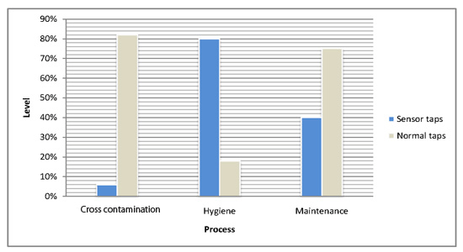Solving Multiple Issues with Electronic Faucets  
These issues can be reduced significantly by replacing the manual faucets with the LYKOR Automatic Touch-Free Sensor Faucets. These faucets are not only reasonably priced, but also because they save the most amount of water. These faucets will reduce water consumption by over 30% which will create a significant dent in the amount of water consumed which will in effect reduce the water bill for UT Dallas. The LYKOR faucet is a modern looking device that will help UT Dallas become a greener and more environmentally friendly campus. Using electronic faucets will help reduce the transfer of germs and bacteria among students. (Lindamood) Students will no longer have to touch a dirty and unhygienic faucet knob.

Figure 3 Research Courtesy of Autotaps

In a public building, there are hundreds, if not thousands, of students every day who use the bathroom. The bathroom is already an unhygienic place, replacing manual faucets with electronic faucets is a simple and effective solution to reduce amount of germs that are spread between students. This will help reduce the health risk that public places often have trouble with. As can be seen in the graph above, the hygiene level of an electronic sensor faucet is more than triple that of a manual faucet which also causes a high level of cross contamination. In the electronic faucets cross contamination is almost fully eliminated as there is no need to physically touch anything to turn the water on. The study by Autotaps even shows that there is less maintenance involved with electronic faucets because of the on/off nature of the device. There are no moving parts externally that could be damaged and thus as long as the electricity to power the faucets is running, there are no significant maintenance issues. (Autotaps)   
  
The Push for LEED Certification  
UT Dallas has committed itself many times publicly and released numerous press articles on its website (as quoted earlier) that it is working towards a more leaner and efficient campus in terms of water. Having electronic faucets will help bring the university one step closer to a LEED certification for the ECS building. This can be the first step to implementing electronic faucets campus wide and creating a significant cost saving for the campus as well as helping to promote a forward thinking and green campus.

# Savings--Student #2

## Dripping Faucets

In the ECSS and ECSN buildings there are 52 total faucets. Of the 52 faucets, six of them are constantly dripping at a rate of ten drips per minute each. According to the U.S. Geological Survey, this leads to about 86,400 drips per day which is equal to two gallons. This leads to 1460 gallons of water being wasted each year. According to the fees stated on the Richardson water website, all this wasted water costs UTD and additional $656 each year.

## WaterSense Faucet Savings

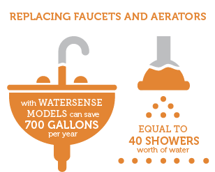The faucet we chose is a WaterSense certified touch free water faucet. According to the United States Environmental Protection Agency, WaterSense models save about 700 gallons per year for every three faucets. “WaterSense labeled bathroom sink faucets and accessories that use a maximum of 1.5 gallons per minute can reduce a sink's water flow by 30 percent or more from the standard flow of 2.2 gallons per minute without sacrificing performance” (EPA, 2014). In the ECSS and ECSN buildings, there are 52 total faucets. By switching to WaterSense faucets, UTD will save 9100 gallons of water each year. By using the rates on the Richardson water website, UTD will save $4080 each year in water costs.

## Touchless Faucet Savings

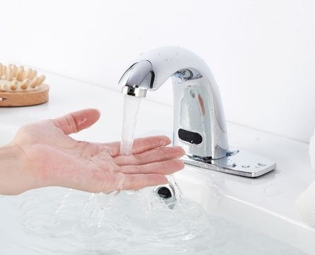When using a regular faucet, people keep the faucet running for a long period of time while doing other things. Men usually comb their hair while the faucet is still running wasting water for long periods of time. Women also waste water by leaving the faucet running while touching up on makeup and fixing their hair. “Getting ready while leaving the water running can cause anywhere from 3-5 gallons of wasted water” (Hollinger, 2012). With the LYKOR Automatic Touch-Free Sensor Faucet, UTD will be saving all that water that would otherwise be wasted. This faucet features a 15 second auto shut off feature where if it does not sense a hand within 15 seconds of the last detected hand, it will shut off the water. This will save a great amount of water since the water would shut off until the person puts his or her hand under the sensor again. If a faucet is running only an extra 10 seconds every 5 minutes, the cost of wasted water would add up quickly. Based on an 8 am to 8 pm class schedule and 300 days of operation to take into account for low use holidays and weekends, the 52 faucets currently installed will be wasting about 3245 gallons of water per year only considering peak hours. By switching to the LYKOR Automatic Touch-Free Sensor Faucet, which uses 1.5 gpm and has an auto shut off feature, UTD will be saving $1455 every year just for the ECSS and ECSN buildings.

Also, according to the U.S. Geological Survey there are about three faucets left running for a long period of time for every 48 faucets a commercial building has. With the LYKOR Automatic Touch-Free Sensor Faucet, UTD can completely get rid of that issue in the ECSS and ECSN buildings since these faucets have the 15 second automatic shut off feature.

## Total Yearly Savings

|  |  |  |  |
| --- | --- | --- | --- |
| Item | Number of faucets affected | Gallons Saved Per Year | Saving Per Year |
| Dripping Faucets Fixed | 6 | 1460 | $656 |
| WaterSense Certified Faucets | 52 | 9100 | $4080 |
| Touchless Faucets | 52 | 3245 | $1455 |

**Total Yearly Savings**

|  |
| --- |
| **$6191** |

## Environmental Savings

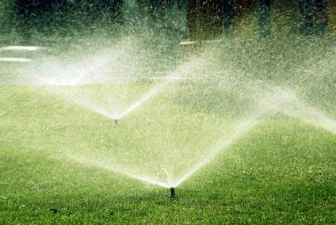Many people overlook the long term environmental benefits of conserving water. The city of Richardson is currently in a stage 3 water restriction which limits outside watering for residents to converse water. By switching to the LYKOR Automatic Touch-Free Sensor Faucets, UTD will be saving 13,805 gallons of water every year. According to the United States Environmental Protection Agency, watering an average size lawn requires 96 gallons of water. The amount of water saved by UTD every year will be enough to water 3 houses’ lawn, every week for the entire year. This may not seem a lot, but this is one step in saving water which would be wasted otherwise. Also this is only the savings for the ECSS and ECSN buildings, switching the faucets in the other buildings would help save even more water.

## Final Thoughts

Switching to the WaterSense certified LYKOR Automatic Touch-Free Sensor Faucet, UTD will be saving over $6191 every year. Besides saving money, UTD will be helping the environment by saving over 13,805 gallons of water every year. These are the savings for just the ECSS and ECSN buildings. If UTD decides to implement this plan beyond these two buildings or even the entire campus, these savings would grow drastically.



## **Reducing Cross Contamination in the Bathroom – Student #3**

## In conventional faucets which are turned on by direct contact such as turning a lever or spinning a handle, this leads to the transfer of what was on the persons hand to the surface of the faucet. Since the handle is repeatedly used, previous germs and viruses are transferred to the next user, and the surface also gains contaminants from each new user all while transferring germs to them. To sanitize the faucets is a never ending process and thus inefficient, but removing the contact would remove the threat of transfer of these germs. The transfer of germs stems from the direct contact of the user with the faucet, thus with a touch less faucet, this need for direct contact is removed. As the sinks are used throughout the day, the number of exposures to the infected surface increases. In addition to this, the manual faucets have to be turned off after the user washes their hands, which leads to recontamination when turning the faucet off.

One of the greatest benefits of a touch-less system is that it removes the necessity to touch the surface of the faucet handle to turn it on. There is no physical contact with any surface of the faucet which results in the fact that there is no transfer of germs and viruses to the faucet handle.  
  
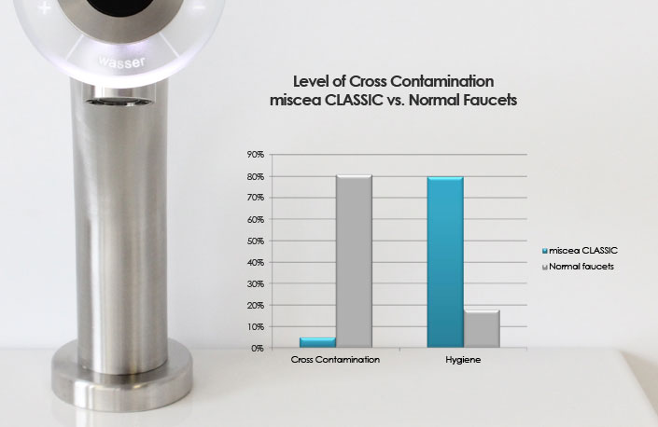

## Touchless Faucets Help to Increase Hand Washing

According to a research survey done by Sloan Valves, touch-less faucets actually encouraged people to wash their hands. Removing the need to manually operate the faucets, with instant turn on when the person’s hands were passed by the sensor, led to more frequent use of the faucets by users of the survey restrooms, thus causing people to be more hygienic. There is also a built in time limit installed within the touch-less faucets which allows them to run for a short duration and then have to be activated again; Sloan found that because of this break in the water flow users were more likely to soap their hands and then re-activate the sensor. When using a faucet to get the optimal level of cleanliness is to wet hands and then apply soap for 10-15 seconds and then wash hands again, this gives a deep clean and removes the up to 75% of germs. Thus, by replacing the current system with the touch-less system it would result in habitually more users washing their hands due to a mental time saving bias and would result in overall cleaner hands from the placement of soap pumps and the timing of the faucets.

Touchless Save Money and Reduces Health Liabilities

Touch-less faucets are optimal for high traffic use of the sink, which for manual faucets would lead for 80 million germs transferred per second on the faucet surface. But with the touch-less system no contact is made with the faucet and this leads to an increase in cleanliness and user hygiene. Due to no physical contact the durability of these systems is also increased as there is no wear and tear from human contact. Coupled with the reduced maintenance costs, and 77% savings in water and energy consumption, the touch-less faucet system is cost effective and efficient to handle ECS’s current and future demands. All while remaining a green initiative, adding modern aesthetics and functionality, and most importantly  
  
New Electronic Faucets are Safer than Before

A study conducted by John Hopkins Hospital found that touch-less faucets actually contained more Legionella spp and heterotrophic plate count (HPC) cultures, a type of bacteria, than manual faucets. They took cultures from all faucets and found that 50% of the electronic ones had the bacteria cultures, while only 15% of the manual ones did. A second test using flushing the water system with chlorine dioxide and testing resulted in 29% of the hands-free faucet cultures were still tainted with bacteria, versus just 7% of the manual faucet cultures. John Hopkins concluded that the sophisticated valves that make up the electronic faucet encourage higher contamination levels. By using our touch-less faucet system which features a hermetically sealed pump system which reduces the complex valve system that would result in greater surface area for bacteria to contaminate, thus leading to a more hygienic touch-less faucet system and a drastic reduction in contamination levels which would lead to better sanitation as compared to the manual faucets.  
  
It is the Logical Forward Thinking Solution

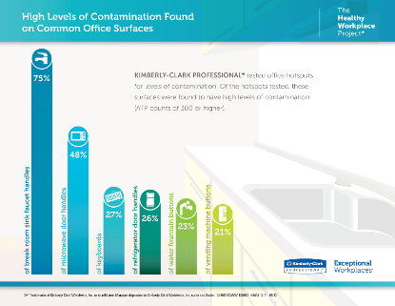The benefits of installing touch-less faucets in place of the manual faucets would be that the hygiene standard of UT-Dallas would be raised and the current system would be modernized. In a university that is ever expanding with class sizes ranging around 30 students there is a lot of close contact between students and any contact can lead to germs being transmitted. But by installing touch-less faucets, it would help increase the chance that someone would use the restroom would also wash their hands afterwards.

# Materials Cost –Student #4

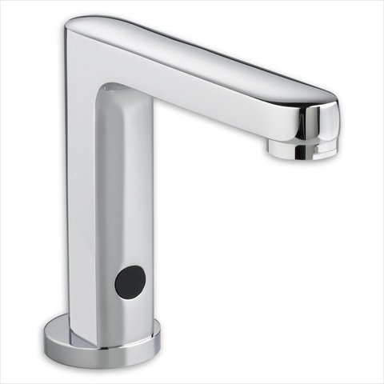For simplicity and savings maximization, we choose to replace all 52 faucets within the Engineering and Computer Science (ECS) buildings. Keeping the faucets consistent throughout the building additionally makes maintaining them simpler, as only one set of replacement parts would be required. The faucet we chose is the LYKOR Automatic Touch-Free Sensor faucet and costs 71 dollars per unit. Other models that were quoted include the American Standard 605XTMV1070 ($96.00) and the Delta commercial 601R040 ($355.00) (Amazon 2014). I have included pictures of these units for comparison.

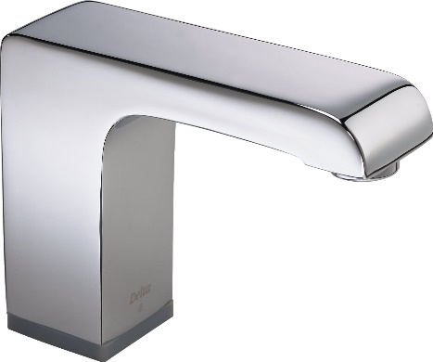

The Delta commercial 601R040 faucet.

The American Standard 605XTMV1070 faucet.

These options prove to be more expensive, and may not heed all of the hygienic benefits provided by the LYKOR faucet due to a lack of hermetically sealed valves. Additionally, the LYKOR faucet allows itself to be wired for a standard 120V plug instead of battery, which is necessary for as big as building as ECS. It also includes the US standard fittings and hardware required to attach it to any sink. Disadvantages of using automatic facets such as these are that temperature must be set in advance. Because of this the user must use the cold water that many buildings provide with automatic faucets. This, however, is a benefit to many companies, as using hot water for washing or cleaning is expensive. These automatic faucets must also be repetitively turn on if the faucet is in use for a long time, which can annoy some users. We expand the cost of facets/building materials in the following table. Note that we add the miscellaneous cost of materials such as extra piping, drywall, and caulking into the table below for a more accurate cost estimate. Metal wastes from the removed faucets would be recycled.

|  |  |
| --- | --- |
| Item | Cost |
| 52 x Lykor Faucet | $3692.00 |
| 52 x Building Materials | ~$1000.00 |
| Total Cost | **~$4700.00** |

## Labor Cost

|  |  |
| --- | --- |
| Materials | $4,700.00 |
| Labor | $3,000.00 |
| Total Cost | **$7,700.00** |

For the installation of this project we will make use of UTD’s maintenance crew and materials. A crew of 5 will be selected to implement our solution across ECS/N. We assume approximately 5 days of work to finish this project. We assume a nominal wage of 15$ per hour for labor. This estimate is added to the materials cost table to the right to reach the grand total of our project cost.

## Implementation

Funds will be allocated for this project after approval for expected completion date of summer 2015. We will apply for these funds in the spring 2015 semester which marks the end of the 2014 fiscal year for UTD. This time is often when UTD has some of its yearly budget left over to spend on improvements throughout the campus. Due to the necessity of bathrooms and the inconvenience of shutting off water to these buildings in order to complete this project, we advise for the demolition/construction phase to occur during the summer intermission (May 14-May 27). A chart explaining the dates that we advise and the descriptions of the tasks of each days is provided below.

|  |  |
| --- | --- |
| Day | Task |
| May 15 | Deconstruction / Removal of old faucets |
| May 16-17 | Preparation for installation of new faucets |
| May 18-19 | Installation of Faucets, calking, final touches |

This way, we will be able to have low student/faculty impact whilst classes are out for the spring and not yet beginning for the summer. The lack of students in the buildings will also be beneficial for the transport of materials and trash inside and outside the building for this project.

Spring 2016 will mark the expected 1 year mark for this project. At this point in time we shall prepare a report on the saving and satisfaction by patrons in the buildings. We will present these findings with the hope that the benefits provided by switching to touchless faucets will serve as a possible reason for expansion to other buildings and departments at UTD. We will also update the UTD sustainability office on our efforts to making UTD and greener campus, with the hope that the ECS building may one day also be LEED certified. Touchless faucets are installations that are in fact a consideration when awarding LEED certifications, given that they provide advances in saving water through reduced flow and sensing techniques (Oras 2014). This project will lead the Erik Jonsson School and eventually all of UTD to a greener and more hygienic future. Additionally, at a total project cost of roughly 8,000 dollars, UTD can save money after the break even period of one to two years.

# Conclusion-Student #5

While touchless faucets go by a number of different names—hands free, electronic, motion activated, sensor—they are all geared toward improving hygiene, simplifying cleaning and maintenance, and conserving water and energy. Touchless faucets are useful in public settings since they assist in stopping the spread of germs, conserve water, and reduce cleanup time. Touchless faucets also help minimize vandalism done to the facilities—individuals who stop up the sink and let the water run. The most significant benefit of touchless technology is the impact on sanitation and cleanliness achieved among restroom users. With increasing publicity about widespread epidemics and other contagious infections, the public is sensitive to hygiene and wary of touching objects that have been handled by scores of other patrons. Hands-free faucets in public facilities encourage more hand washing and which in turn help prevent infections and other contagious diseases. Touchless faucets minimize the chance users will come in contact with bacteria or germs on the surface of restroom controls. Eliminating the need for contact by itself typically results in users giving the cleanliness of the restroom a higher rating. “Touchless technology is a good idea, because hard surfaces are significant transfer points for bacteria and viruses,” says Charles Gerba, PhD, a microbiologist at the University of Arizona, Tucson. “Much of what people put down on a surface can be picked up by the next person who comes along, and in an age where people share more spaces and surfaces than ever before, touchless technology can help prevent cross-contamination” (Going Touchless). Investing in this high-quality commercial plumbing fixtures will pay back its initial cost over a short time in a number of ways. The water and energy saving features minimize service and operational costs, and the improved washing, hygiene, safety and convenience aspects will resonate with all facility users. Choosing a high-quality and durable product will translate into less upkeep and maintenance, saving costs on upkeep, repairs, parts and replacement products and frees up time for staff to focus on other duties. As a result, building management experience superior, long-lasting product performance that will benefit their building— and end-users—for years to come. Nice-looking and efficient public restrooms offer significant benefits. For the facility manager they can contribute a lower amount of complaints and repair tickets.

# Works Cited

Larson EL, Albrecht S, O’Keefe M. Hand Hygiene Behavior in a Pediatric Emergency Department and a Pediatric Intensive Care Unit: Comparison of Use of 2 Dispenser Systems. American Journal of Critical Care. 2005;14: 304-311.

"Going Touchless Is a High-Tech Solution to Hand Hygiene Compliance." Going Touchless Is a High-Tech Solution to Hand Hygiene Compliance. Informa Exhibitions LLC, 23 July 2008. Web. 07 Dec. 2014.

Autotaps logo. (n.d.). Retrieved December 7, 2014, from http://www.autotaps.com/sensor-taps-facts-and-charts.html

Guide to LEED Certification: Commercial. (n.d.). Retrieved December 7, 2014, from http://www.usgbc.org/cert-guide/commercial#tools

Is Rusty Water Safe? (2007, August 1). Retrieved December 7, 2014, from http://www.berkeleywellness.com/healthy-eating/food-safety/article/rusty-water

Lindamood, K. (2009, October 28). What Are the Dangers of Corrosion on Faucet? Retrieved December 7, 2014, from http://www.ehow.com/facts_5583609_dangers-corrosion-faucet_.html

Sustainability: Water. (n.d.). Retrieved December 7, 2014, from <http://www.utdallas.edu/sustainability/water/>

Outdoor Water Use in the United States. (n.d.). Retrieved December 6, 2014, from http://www.epa.gov/WaterSense/pubs/outdoor.html

Water Science ActivitiesDrip Calculator: How much water does a leaking faucet waste? (n.d.). Retrieved December 6, 2014, from http://water.usgs.gov/edu/sc4.html

Fees and Rates. (n.d.). Retrieved December 6, 2014, from http://cor.net/index.aspx?page=1635Hollinger, J. (n.d.). Saving Water Makes Good Sense. Retrieved December 6, 2014, from http://www.dec.ny.gov/lands/5009.html

Water Conservation Tips - How to Save Water. (n.d.). Retrieved December 6, 2014, from <http://www.dpwater.com/Water_Conservation/Water_Conservation.htm>

Watson, J. (n.d.). Facilities Come Clean with New Plumbing Fittings. Retrieved December 9,2014, from https://www.sloanvalve.com/Water_Efficiency/Construction_Specifier_3.07.pdf

Touchless, ADA-compliant handwashing products spearhead hygiene initiative. (n.d.). Retrieved December 9, 2014, from http://www.sloanvalve.com/Project_Portfolio/Sabre_Room.aspx

Renner, J. (n.d.). A Touchy Subject. Retrieved December 9, 2014, from http://plumbingengineer.com/april_12/faucet_feature.php

Maragakis, L. (2011, March 21). Latest Hands-Free Electronic Water Faucets Found To Be Hindrance, Not Help, In Hospital Infection Control. Retrieved December 9, 2014, from http://www.hopkinsmedicine.org/news/media/releases/latest_hands_free_electronic_water_faucets_found_to_be_hindrance_not_help_in_hospital_infection_control

Nichols, S. (2007, September 1). Touchless Technology Helps Facilitate Infection Prevention Best Practices. Retrieved December 9, 2014, from <http://www.infectioncontroltoday.com/articles/2007/09/touchless-technology-helps-facilitate-infection-p.aspx>

Oras. (2014). Green Building & LEED Faucets. Retrieved December 9, 2014, from <http://www.oras.com/en/professional/products/producttypes/Documents/green_building.pdf>

Amazon. (2014). Amazon Search: Faucets. Retrieved December 8, 2014, from http://www.amazon.com/s/ref=nb_sb_noss?url=search-alias%3Dtools&field-keywords=amazon+kitchen+faucet+touchless&rh=n%3A228013%2Ck%3Aamazon+kitchen+faucet+touchless